Pages 29 - 39 in ***Java Programming A Comprehensive Introduction***

**Section 1: Define**

control statements- Control statements may be used to control the execution sequence.

If (*condition*) statement- Conditional statements are used to perform different actions based on different conditions.

Boolean Expressions- an expression in a programming language that produces a Boolean value when evaluated, i.e. one of true or false.

Relational Operators- a programming language construct or operator that tests or defines some kind of relation between two entities.

**(Define Each Symbol)**

**< less than**

**<= less than or equal to**

**> greater than**

**>= greather than or equal to**

**== equal to**

**!= not equal to**

Import statement-

(Scanner class is not explained thoroughly in the given text. Here is an online resource to hopefully make the point more clear.

<http://www.cs.utexas.edu/users/ndale/Scanner.html> )

What does java.util.Scanner and **new** Scanner (System.in); allow the programmer to do?

They both allow programmer or user to input a value

constructor- a class is a special type of subroutine called to create an object. It prepares the new object for use, often accepting arguments that the constructor uses to set required member variables.

Code block- a free, open source cross-platform IDE which supports multiple compilers including GCC, Clang and Visual C++.

loop- a method of control loop

**for**(initialization; condition; iteration)statement;

loop control variable- initialized, tested, and changed as the loop executes. It is an ordinary int variable, but it is used in a special role

Code block- a free, open source cross-platform IDE which supports multiple compilers including GCC, Clang and Visual C++.

Import statement- Enables type names to be referenced without namespace qualification.

What does java.util.Scanner and **new** Scanner (System.in); allow the programmer to do?

They both allow programmer or user to input a value

**Programming Assignments**

Task 1 –

Page 39. **in *Programming A Comprehensive Introduction***

**Update your program from Assignment 2, Task #2**

Allow the user to input their weight for the earth weight to moon weight conversion problem. Add an **if** statement that prompts the user if she inputs 0 or a negative number for her earth weight.

**#13.** The moon’s gravity is about 17 percent that of the earth’s. (Meaning you weigh less on the moon). Write a program that computes your affective weight on the moon.

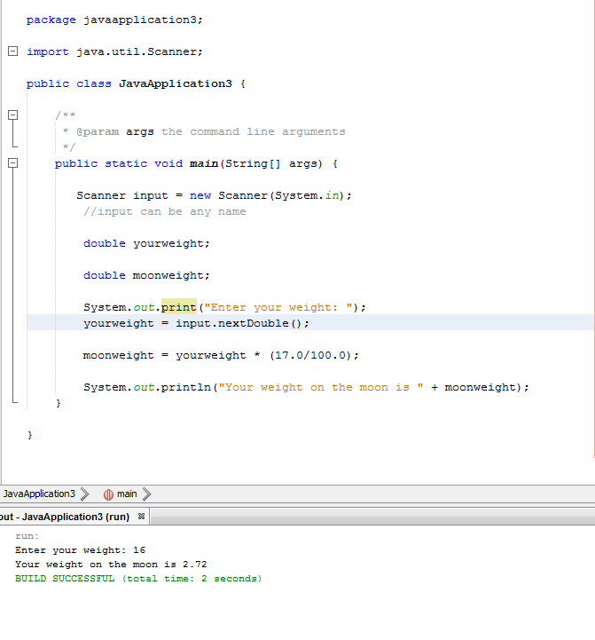

Task 2-

Page 39. **in *Programming A Comprehensive Introduction***

#14 (modified)

Adapt Try This 1-2 so that it prints a conversion table of inches to meters. Display **3 feet** of conversions, inch by inch. **(36 inch to meter conversions)** Output a blank line every 12 inches. (One meter equals approximately 39.37 inches.)

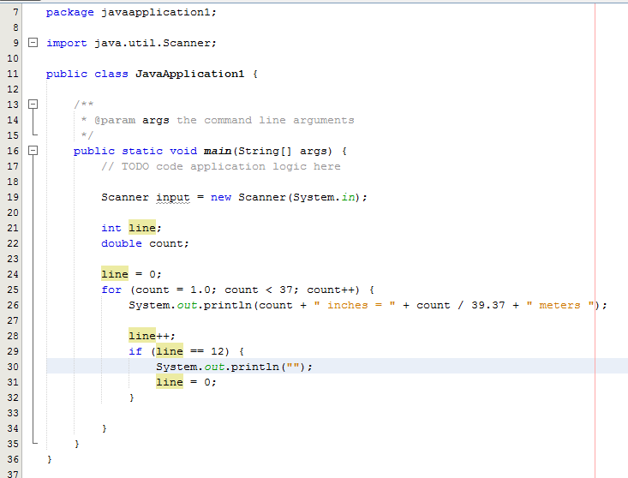

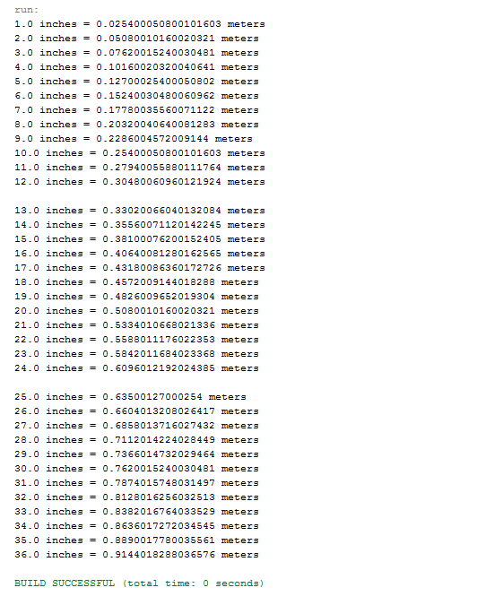

Task 3-

Pg. 41 # 29

Write a program that prints out the first 20 squared numbers**.** Starting at x = 1 until x = 20. **Do not use java.lang.Math**

Create a line counter variable that inputs a blank line every 5 lines.

Display outputs as shown below.

1 squared = 1

2 squared = 4

3 squared = 9

4 squared = 16

// Every 5 lines create a blank line.

5 squared = 25

6 squared = 36

7 squared = 49

Continued….

